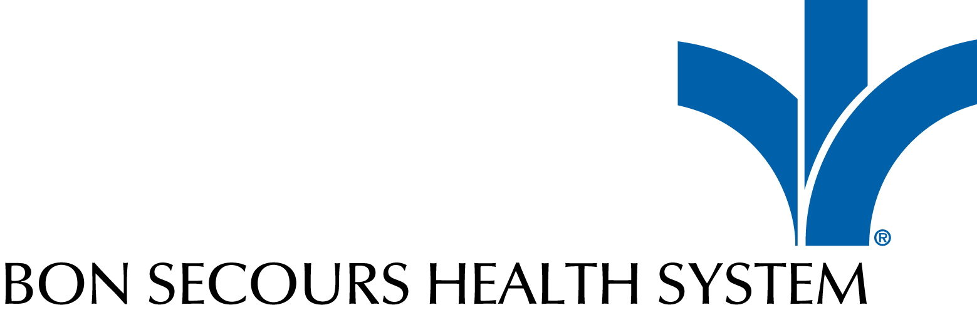
Bon Secours Health System Awards Ceremony 2022
Quality Improvement

Category Nomination Guidelines
The Quality Improvement Award will be given to an individual or team whose efforts supported the Bon Secours Group goals of quality. This individual / team must have collaborated towards a common quality improvement goal and contributed to the success of the organisation. The award recognises a person or team whose quality improvement has improved patient / staff safety; patient care and experience; or quality of service in line with Goal 2 of the 2025 plan, Exceptional Care. Either an individual or a team may be nominated for this award.
Marking Criteria
Quality Improvement Details | What impact did this change achieve to patient/staff experience and/or financial performance
Quality Impact | Improvements to quality of the services
Collaborative Working | How the nominee worked collaboratively to achieve this quality improvement
Sustainability | What measures are in place to ensure this quality improvement will be embedded and sustainable?
Implementation | Can it serve as a model that other departments can implement within the Bon Secours Health System?
Requirements and Eligibility
- The nominee must be an employee, Consultant, Volunteer or contracted staff member who has been embedded in the Bon Secours Health System for at least six months on or before the closing date for nomination.
- Nominees can be any grade/level of staff.
- Nominees must not have any performance/disciplinary issues within the past year.
- Nominees must exemplify the Bon Secours mission/vision statements and core values.
- The nomination must be endorsed by the Hospital CEO
Submission Process and Instructions
Completed forms should be uploaded via the online nomination page. Optional Supplementary materials should be included in the appendix and limited to three pages. The deadline for nominations is 12th August 2022.
Application Review Process
All applications will be reviewed by a Judging Panel, which includes Bon Secours Health System Executive and Non-Executive members and leaders from outside the organization. The shortlist will be announced on the week of the September 7th and the event will take place on 7th October 2022. Any questions regarding the application process should be directed to nominations@healthawards.ie

Quality Improvement Nomination Form
*Either an individual or a team may be nominated for this award. Fill in Section A) to nominate an individual or section B) if you are nominating a team

A. Individual Nomination
Nominees Name |  | Job Title
Department |  | Site
Phone |  | Email
Line Manager

B. Team Nomination
A team is comprised of three or more team members, including the Team Leader and can be cross functional or work-unit based. This could be either clinical or a back office Team e.g. Finance, Bookings or Admin. One person on the team must be designated as Team Leader.

Team Name
Department |  |  |  | Site
Team Leader |  |  |  | Job Title
Email |  |  |  | Phone
 | Team Members Name |  | Job Title |  | Department |  | Email
1
2
3
4
5
6
7

Hospital CEO’s Endorsement
Name |  | Date of Approval
Dept |  | Site
Work Phone |  | Mobile
Email

Submission – Nomination Text

Please note that all sections are required and must be complete in order to be considered.

- Quality Improvement Details
What impact did this change achieve to patient/staff experience and/or financial performance?
(Please be concise and keep to a 500 word max):

2: Quality Impact
Improvements to quality of the services (Please be concise and keep to a 500 word max):

3. Collaborative Working
How the nominee worked collaboratively to achieve this quality improvement (Please be concise and keep to a 500 word max):

4. Sustainability
What measures are in place to ensure this quality improvement will be embedded and sustainable? Please be concise and keep to a 500 word max:

5. Implementation
Can it serve as a model that other departments can implement within the Bon Secours Health System? Please be concise and keep to a 500 word max:

Appendix (optional)

